PYTHON TO MYSQL & PROJECT
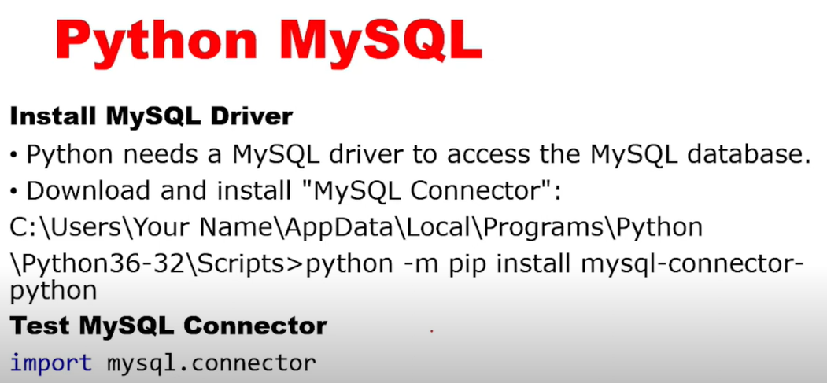
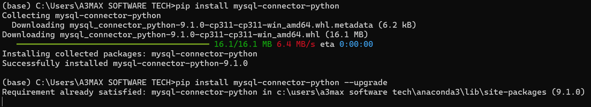
Also user can install from vscode (save as connection.py)
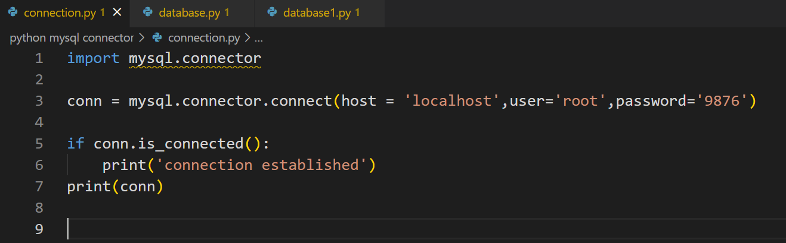
After executing the code you can check the database connection has been established.
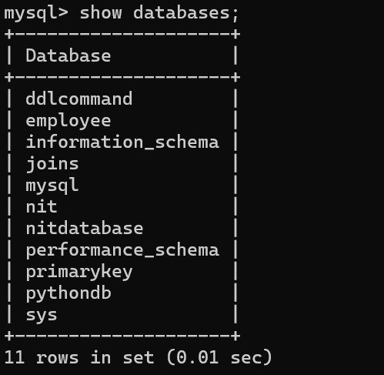

Create another file called as database.py
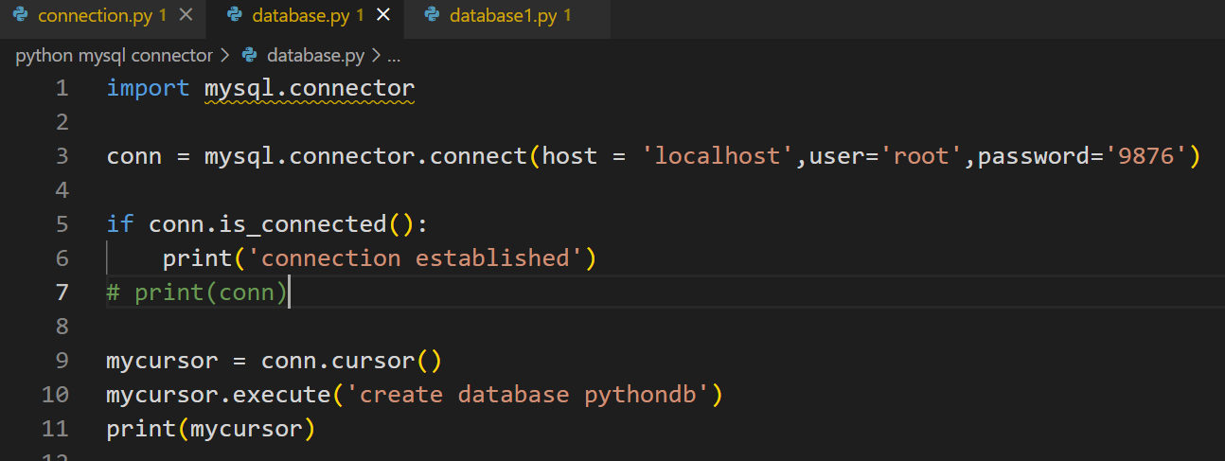
Then save another file as database1.py
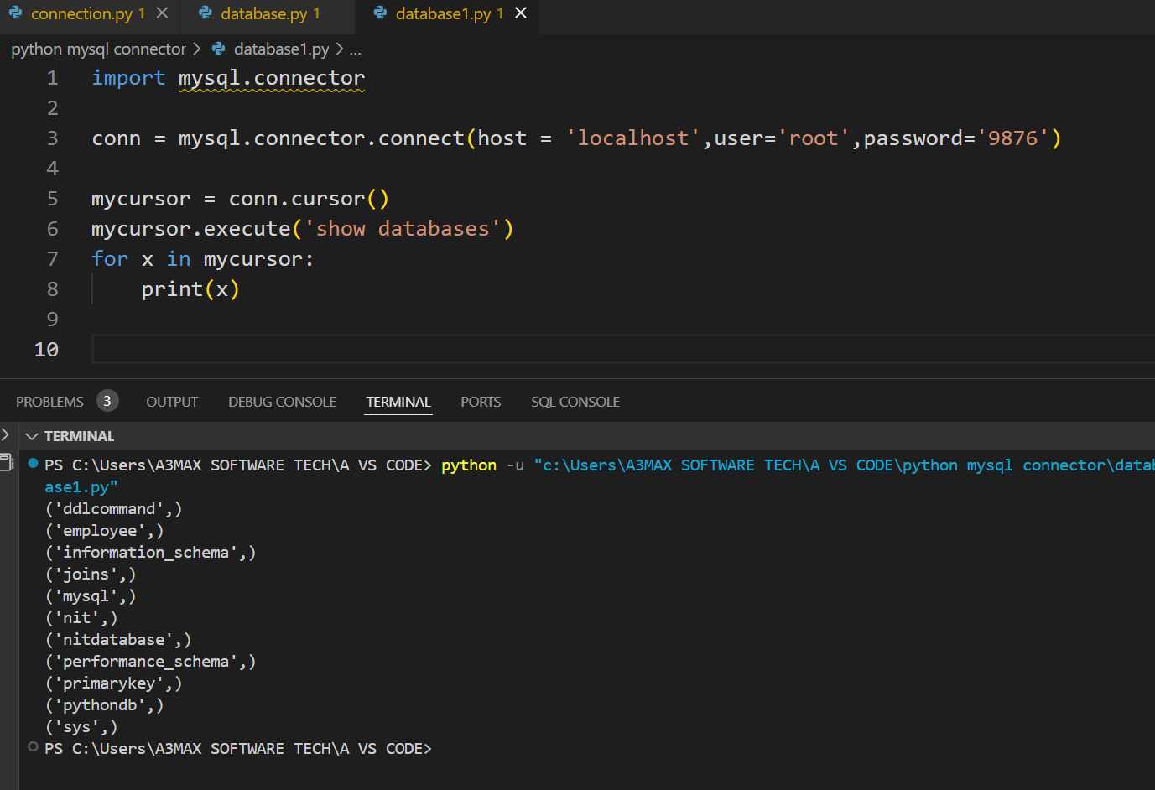
Then save another file as ‘createtable.py’ inside the ‘pythondb’ create student table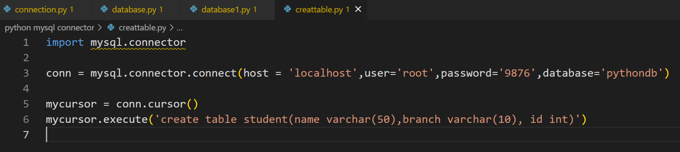

Once table created using python you can see the table in the sql as well.
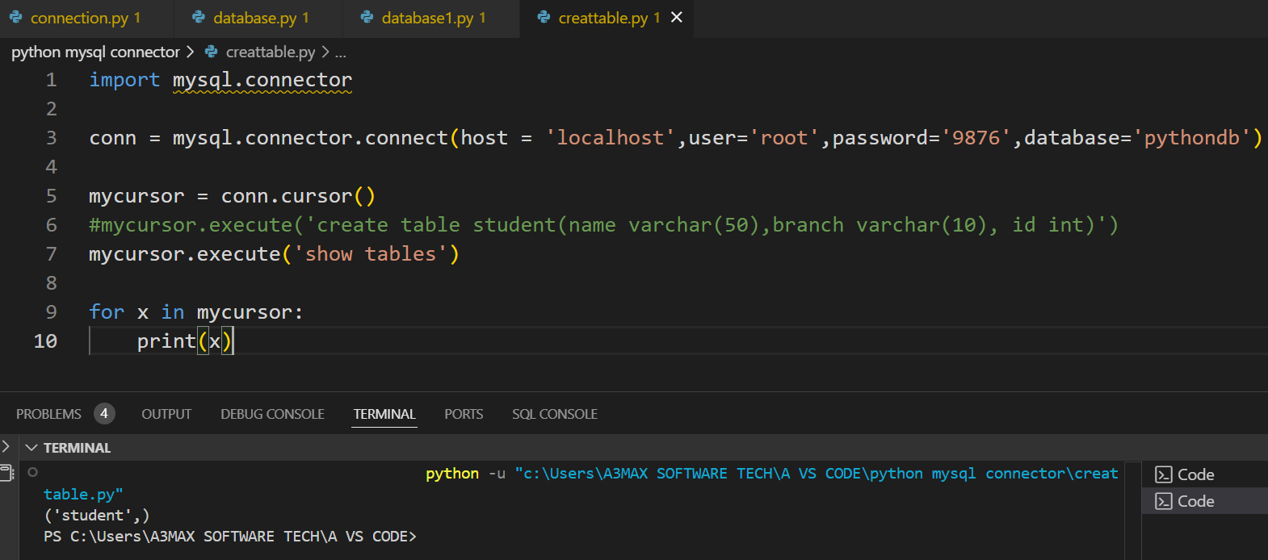
Insert single record to the table – insertvalue.py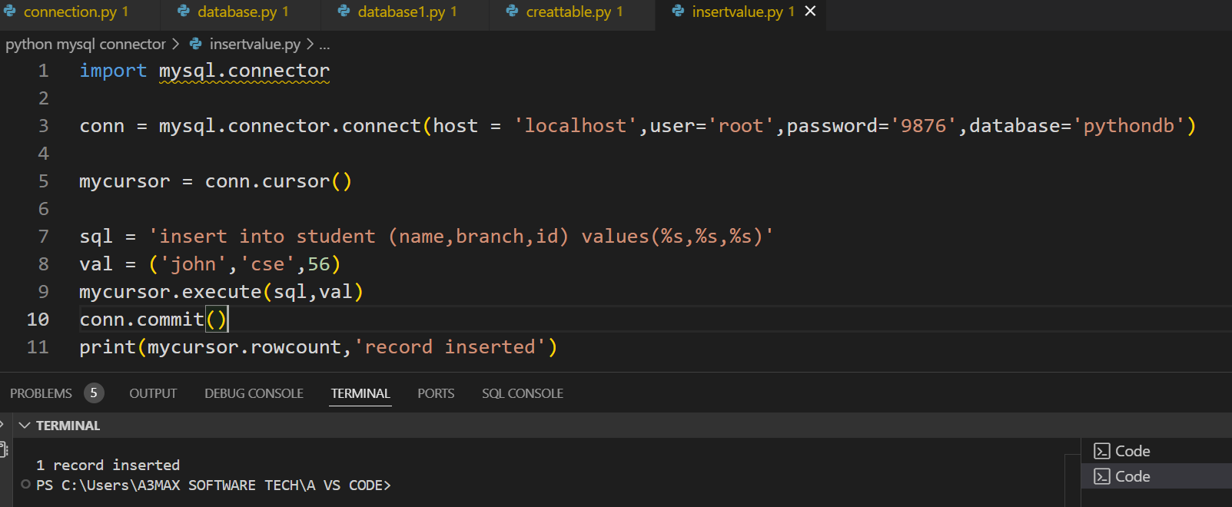
Insert multiple record to the table –
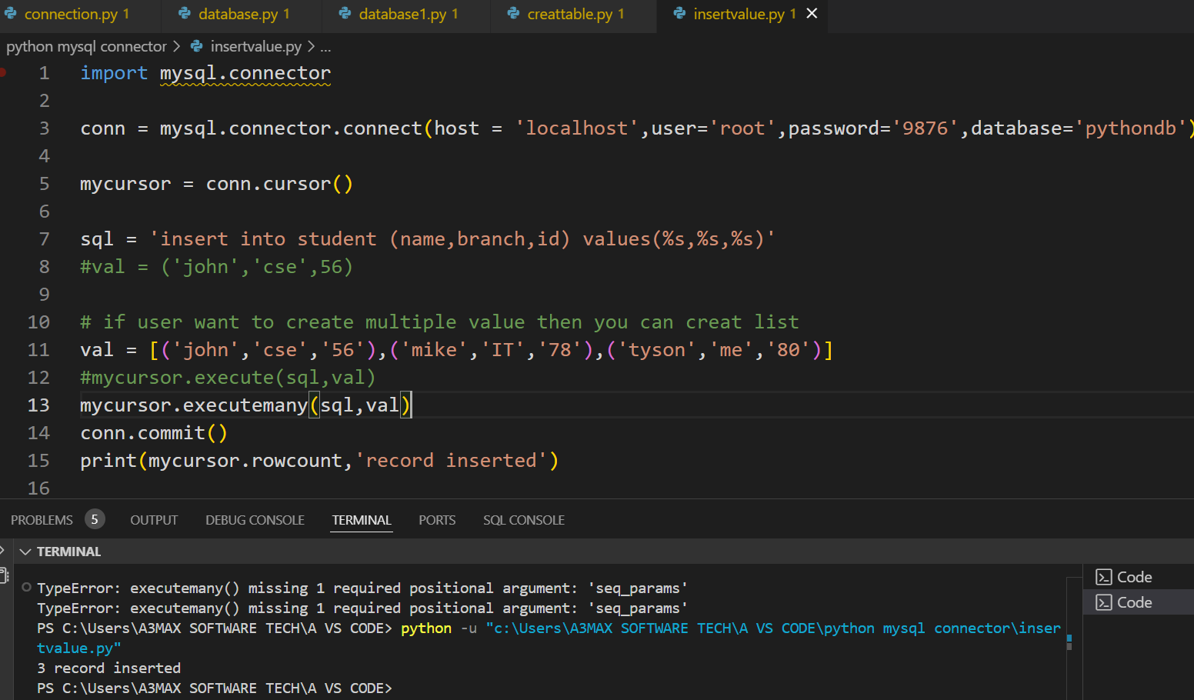
WORK WITH PYTHON PROJECT WITH MYSQL
Save the file with EMPREGISTRATION.PY file
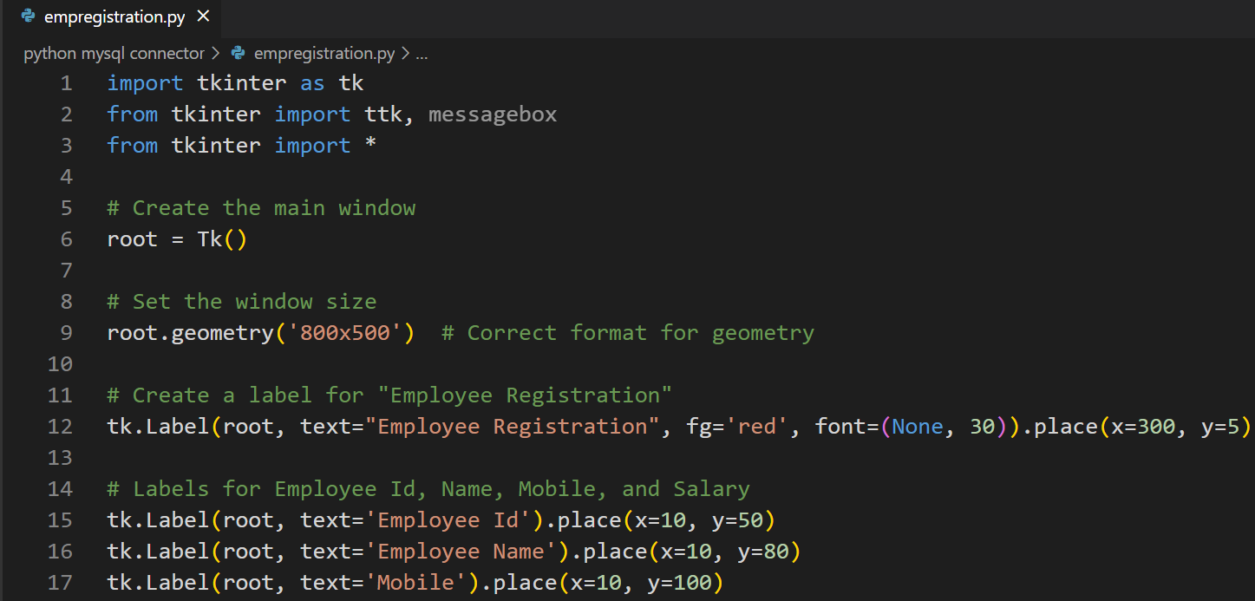
Once execute above code frontend file will be displayed –
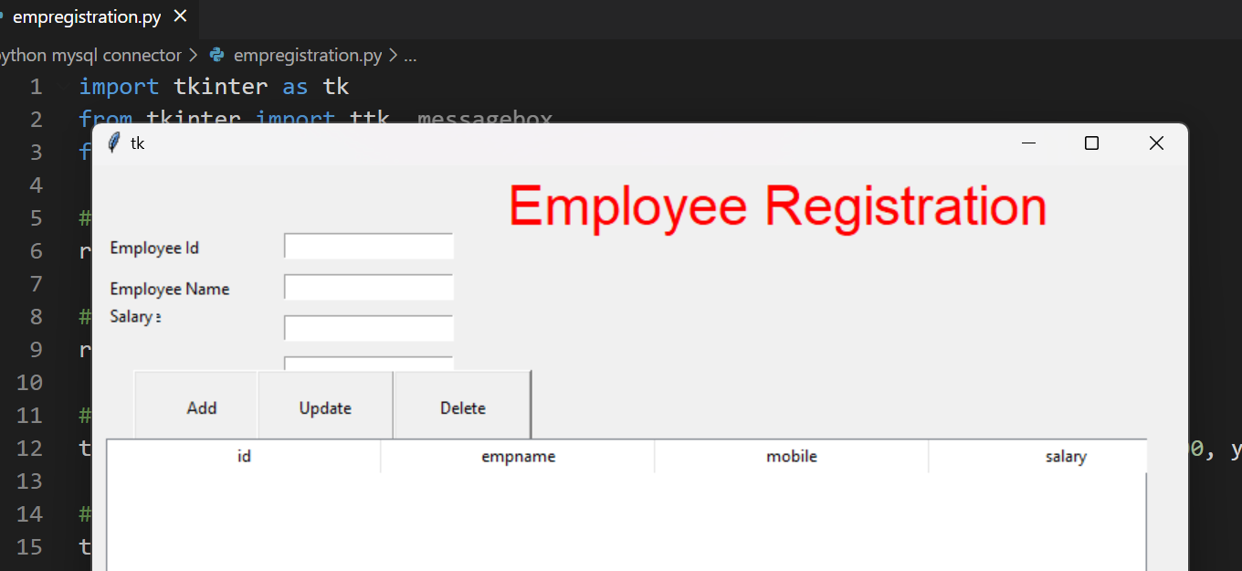
After write the code create new database in mysql tkinter
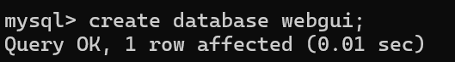
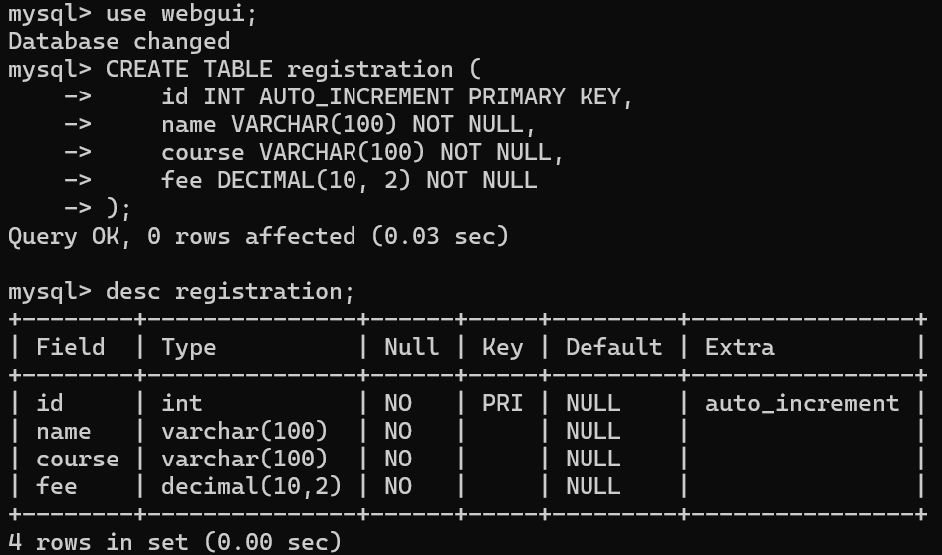
Once you write the backend code then below query will execute
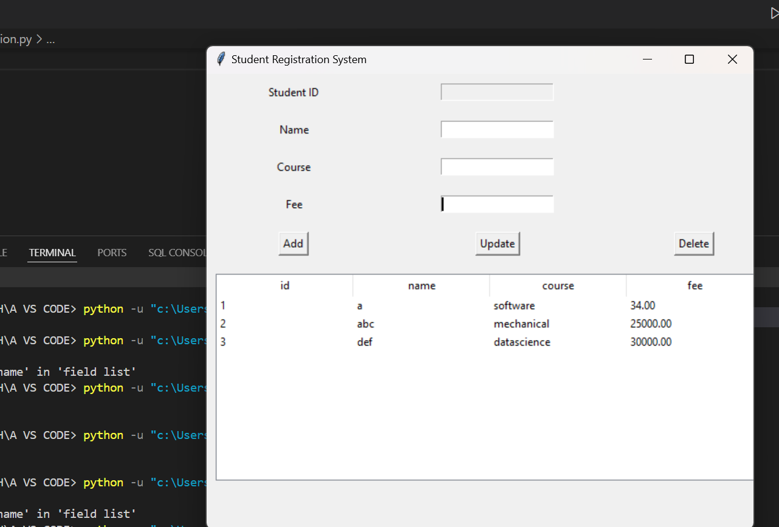
Then you can check to the database – all records will be added.

